> head(max(average_acc_history$validation_acc))

[1] 0.8342998

> head(eval)

loss categorical_accuracy

0.8826595 0.6623530

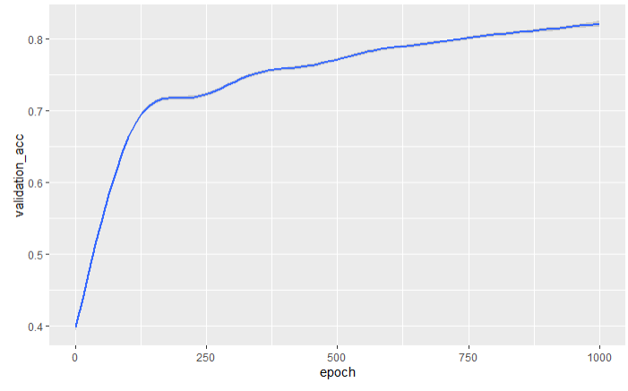

build_model <- function() {

model <- keras_model_sequential() %>%

#layer_batch_normalization(axis = -1L, input_shape = dim(train_data)[[2]]) %>%

layer_dense(units = 128, activation = "relu", input_shape = dim(train_data)[[2]]) %>%

#layer_dense(units = 128, activation = "relu") %>%

layer_dropout(0.3) %>%

layer_dense(units = 1024, activation = "relu") %>%

layer_dropout(0.3) %>%

layer_dense(units = 1024, activation = "relu") %>%

layer_dropout(0.3) %>%

layer_dense(units = 1024, activation = "relu") %>%

layer_dropout(0.3) %>%

#layer_dense(units = 128, activation = "relu") %>%

layer_dense(units = 128, activation = "relu") %>%

layer_dropout(0.3) %>%

layer_dense(units = 8, activation = "softmax")

model %>% compile(

optimizer = optimizer_sgd(learning_rate = 0.1),

loss = "categorical_crossentropy",

metrics = "categorical_accuracy"

)

}

* Dropouts have a negative effect so far